ETHICAL HACKING

Table of Contents
1. Introduction 3
2. Objectives 3
4. Methodology 4
4.1 Bypass Login Password for Both Operating Systems 4
4.2 Information Gathering 7
4.3 EternalBlue Exploitation 10
4.4 SMB Exploitation 12
4.5 SQL Injection 13
4.6 Pivoting 15
5. Results 16
6. Recommendations 17
7. Conclusion 18
References 20

1. Introduction
This penetration testing report records the red teaming simulation that was conducted in a controlled virtual environment, attacking two systems: Windows 7 Professional and CentOS 7 with Linux Kernel 3.10. The objective of this engagement was to identify any vulnerabilities present in the configurations of one or both systems (May et al., 2025), exploit such weaknesses, and fully document the process. In a way, this is to imitate the method of a real-world intruder trying to launch an unauthorised compromise against systems.
Penetration testing methodologies usually have a structured approach involving four phases: reconnaissance, exploitation, post-exploitation, and pivoting. These stages are more or less known to security frameworks like OWASP, PTES, and OSSTMM (Surya et al., 2024). Each stage has a different objective, i.e., reconnaissance gathers information about the target, exploitation uses vulnerabilities to gain access, post-exploitation works to elevate privileges and explore the internal networks, and finally, pivoting works to move laterally within the environment.

2. Objectives
The primary objectives of the penetration test were as follows:
- Evaluate both operating systems' security posture using black-box and grey-box methods.
- Use practical strategies, such as local and remote exploits, to find and take advantage of vulnerabilities.
- Use lateral movement and privilege escalation tactics to demonstrate complete system compromise.
- Test data exposure and internal network access using reconnaissance and pivoting
- To stop exploitation in a real-world setting, record results and provide mitigations.
3. Scope of Engagement
The course instructor offered a predetermined internal virtual environment in which the testing was conducted. The two systems under analysis were:
- Target 1: Windows 7 Professional
  - Services: SMB (Port 445), RDP, MSRPC
  - Possible Vulnerability: MS17-010 (EternalBlue)
- Target 2: CentOS 7 (Kernel 3.10)
  - Services: Apache (Port 80), Samba, SSH
  - Possible Vulnerabilities: Misconfigured file shares, outdated packages, SQL Injection
All testing activities were performed on the designated and assigned lab machines. No external IPs or any cloud infrastructure were used during the imparting of this assessment, nor was any denial-of-service activity applied (Abdeslam Rehaimi et al., 2024). The engagement was made under the authorised scope of ethical hacking.

4. Methodology
This section describes the thorough methodology employed throughout the testing procedure, beginning with login bypass and moving on to reconnaissance.

4.1 Bypass Login Password for Both Operating Systems
Windows 7 – Sticky Keys Exploit (sethc.exe Trick)
The initial access into the machine running Windows 7, the Sticky Keys backdoor was used. It is a local privilege escalation that uses the Windows accessibility environment sethc.exe to let users open a SYSTEM-level command prompt during the login screen.
Steps taken:
- Forcibly shutting down the computer during bootup puts it back into Startup Repair mode.
- Navigated to the "View problem details" section, which allowed launching Notepad.
- Used the Save As dialogue in Notepad to browse the file system and navigate to C:\Windows\System32.
- Renamed the existing sethc.exe to sethc_backup.exe.
- Copied cmd.exe and renamed the copy as sethc.exe.
- Rebooted the system normally and, at the login screen, pressed Shift five times, which launched a command prompt.
At the command prompt, reset the password:
Net user "Ann Bondman" bondman123
As a result, the machine was given administrative access, allowing for login and more exploitation.
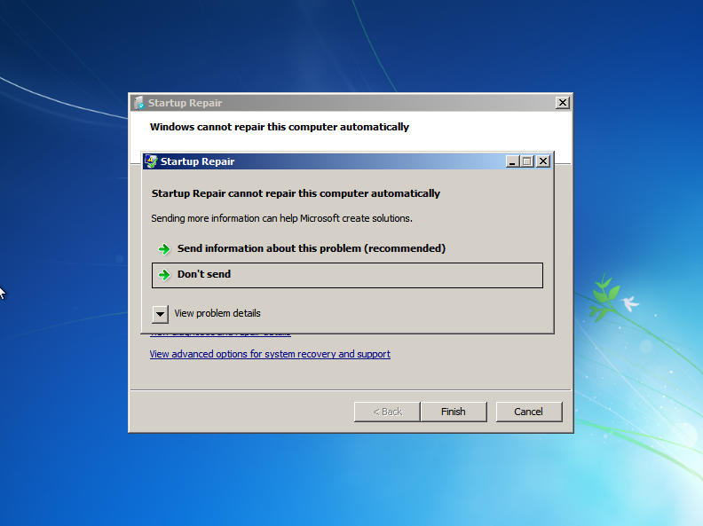
Figure 1: Startup Repair Error Screen on Windows 7
(Source: Self-Created)
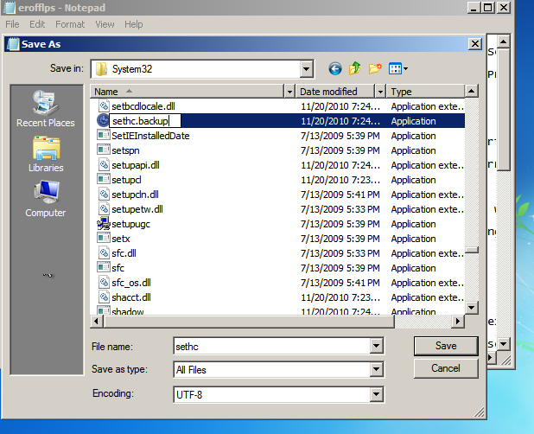
Figure 2: Renaming sethc.exe to sethc.backup for Sticky Keys Exploit
(Source: Self-Created)

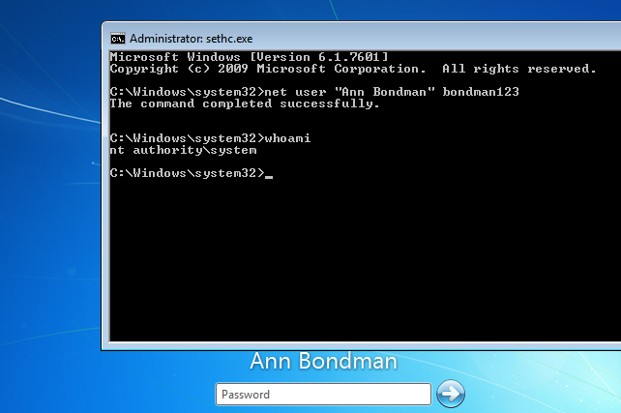
Figure 3: Bypass login password Windows 7
(Source: Self-Created)
CentOS 7 – GRUB Bootloader Root Reset
The GRUB bootloader on the CentOS 7 system was altered to change the root password without revealing the old one (Gonzalez & Napetvaridze, 2025). This technique allows for modification by putting the system into emergency mode and remounting the file system.
Steps taken:
- Rebooted the CentOS machine and interrupted the GRUB boot menu.
- Edited the kernel boot parameters, appending:
- The initramfs emergency shell was used when the system booted up. The root filesystem was then remounted.
- Ran the passwd command to reset the root user’s password.
- Rebooted the machine and successfully logged in as root.
- This technique revealed a crucial configuration flaw that permitted full root compromise: neither SELinux policy enforcement nor the GRUB password.
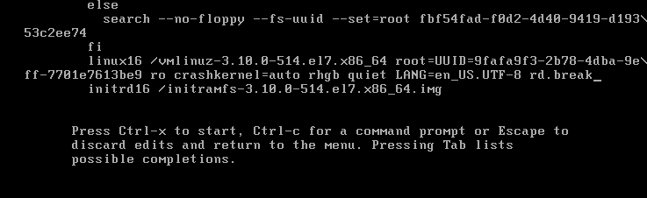
Figure 4: Modifying GRUB Boot Parameters for Root Password Reset in CentOS 7
(Source: Self-Created)
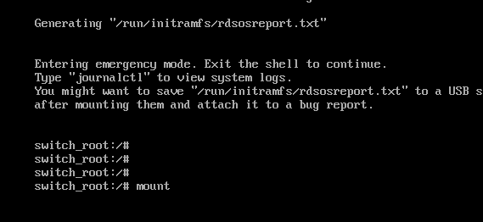
Figure 5: Mounting the Root Filesystem in CentOS 7 to Reset Root Password
(Source: Self-Created)
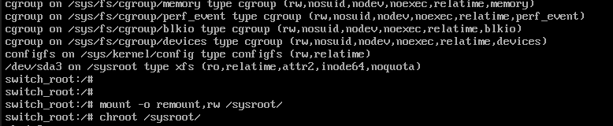
Figure 6: Reset Root Password in CentOS 7
(Source: Self-Created)
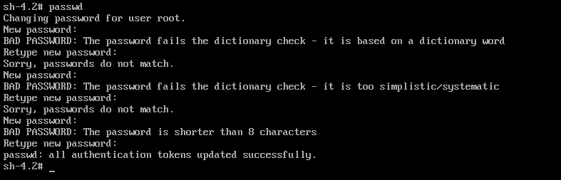
Figure 7: Resetting the Root Password
(Source: Self-Created)

4.2 Information Gathering
Active reconnaissance was carried out using administrator access to both systems to find reachable systems, open services, and possible vulnerabilities.
Netdiscover – Identify Live Hosts
From Kali Linux, used netdiscover to identify live hosts in the 192.168.199.0/24 subnet:
netdiscover -r 192.168.199.0/24
This revealed:
- 192.168.199.6 Windows 7
- 192.168.199.8 CentOS 7
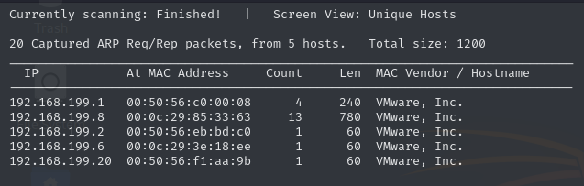
Figure 8: ARP Scan Results Showing Unique Hosts and MAC Addresses
(Source: Self-Created)
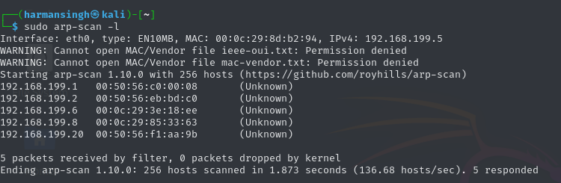
Figure 9: ARP Scan to Discover Active Hosts and MAC Addresses
(Source: Self-Created)
Nmap – Port Scanning
Targeted scanning of both systems was performed using nmap:
nmap -sS -sV -O 192.168.199.6
nmap -sS -sV -O 192.168.199.8
Windows 7 Results:
- Ports: 445 (SMB), 139, 135
- OS Fingerprint: Windows 7 SP1
- Vulnerable Service: SMBv1
CentOS 7 Results:
- Ports: 22 (SSH), 80 (Apache), 445, 139 (Samba)
- OS Fingerprint: CentOS 7, Kernel 3.10.0
- Services: Apache 2.4.6, PHP 5.4.16, Samba 4.x
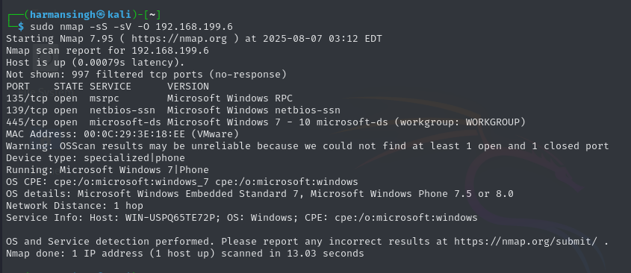
Figure 10: Nmap Scan of Windows 7 Host
(Source: Self-Created)
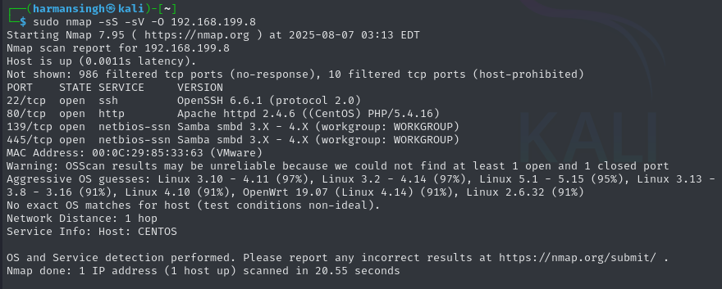
Figure 11: Nmap Scan of CentOS 7 Host
(Source: Self-Created)
Nikto – Web Server Enumeration
To check the web server on CentOS, use:
nikto -h http://192.168.199.8
Findings included:
- Apache 2.4.6 – outdated
- PHP 5.4.16 – vulnerable
- HTTP TRACE method enabled
- Indexing enabled in /reports/ directory
This implied the possibility of additional exploitation through SQL Injection or the exposure of private files.
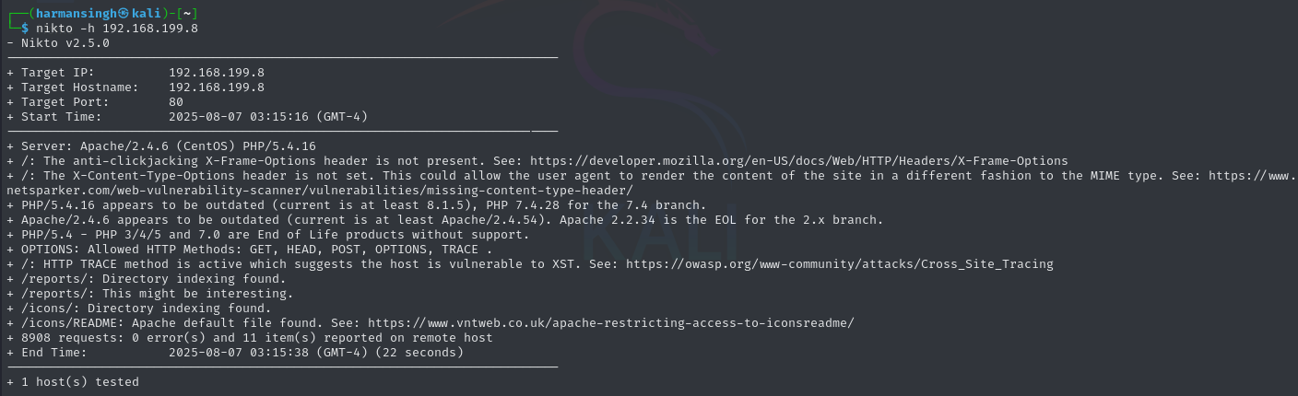
Figure 12: Nikto Scan of CentOS 7 Web Server
(Source: Self-Created)

4.3 EternalBlue Exploitation
The vulnerability in the SMBv1 protocol of Windows enables remote code execution through exploitation. The issue has become quite famous, having been exploited in the WannaCry ransomware attack (Le et al., 2025), chiefly because of the remote execution of arbitrary code without requiring authentication.
This vulnerability on the Windows 7 target was exploited in this engagement using the Metasploit framework. The subsequent actions were carried out:
- Scan: The Windows 7 machine was found to have SMBv1 enabled, rendering it susceptible, according to Nmap and Metasploit.
- Exploit: Using the Metasploit module exploit/windows/smb/ms17_010_eternalblue, the exploit was executed, gaining remote system access.
- Result: After the exploit was successful, a Meterpreter session was launched, giving the target SYSTEM-level access.
This flaw was crucial since it made it possible for remote code execution to occur without authentication, which gave attackers a simple way to take complete control of unpatched systems.
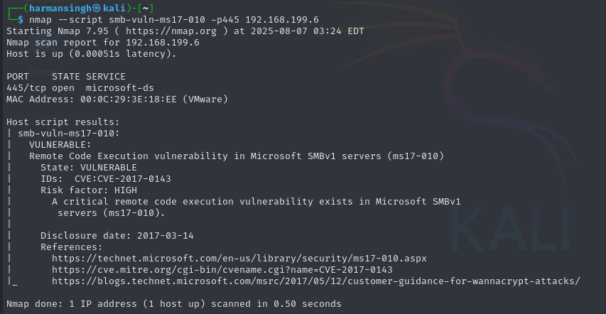
Figure 13: Nmap SMB Vulnerability Scan for MS17-010
(Source: Self-Created)
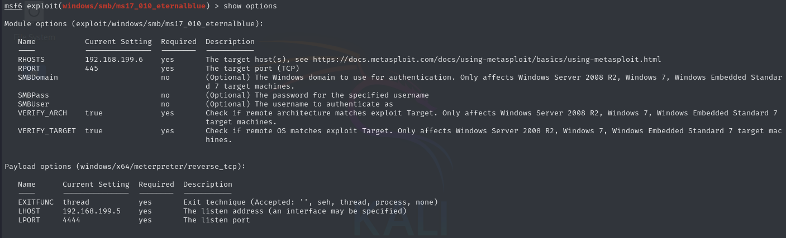
Figure 14: Metasploit Configuration for MS17-010 Exploit
(Source: Self-Created)

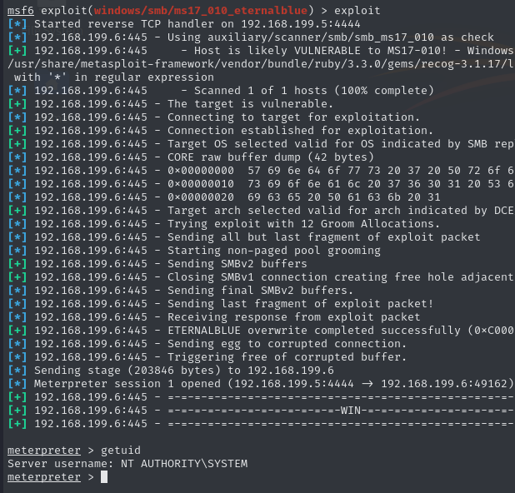
Figure 15: Metasploit Exploit Execution Successful
(Source: Self-Created)
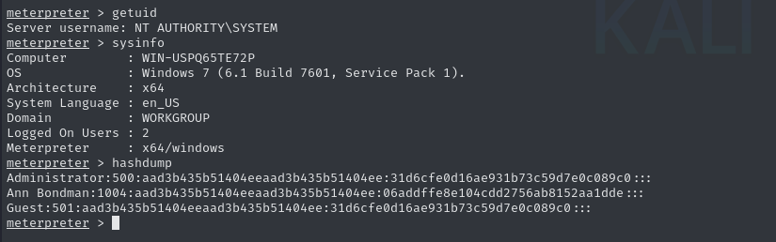
Figure 16: Metasploit: User and System Information Dump
(Source: Self-Created)

4.4 SMB Exploitation
This SMB vulnerability was leveraged to access shared files in the internal network. The exploitation was accomplished through a loose SMB configuration and anonymous access to the shared directories (Alexis, 2021). Using smbclient, we connected to the share "Reports" on the internal host 192.168.199.8.
- The SMB share contained sensitive files such as annual.txt, quaterly.txt, and monthly.txt.
- These files were obtained without authentication because the SMB permissions were not set up correctly.
The exploitation of weak SMB permissions has allowed our team to obtain unprotected files and internal resources that ought to have been protected. It is a high-security risk for the sensitive data residing in SMB shares with no authentication or access controls.
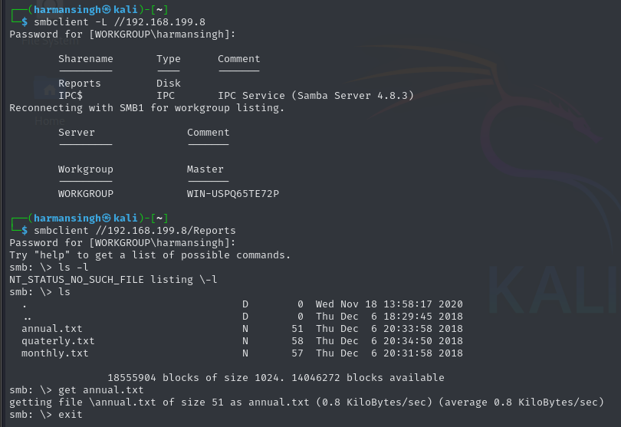
Figure 17: SMB Share Enumeration and File Retrieval
(Source: Self-Created)

4.5 SQL Injection
A web service operating on the CentOS 7 target at IP 192.168.199.8 was the focus of attention after the information collection stage. Credentials seemed to be handled using a regular HTML form on a login page located at /reports.php.
Using a known authentication bypass payload, SQL injection vulnerabilities were tested:
Password: ' OR 1=1; -- <
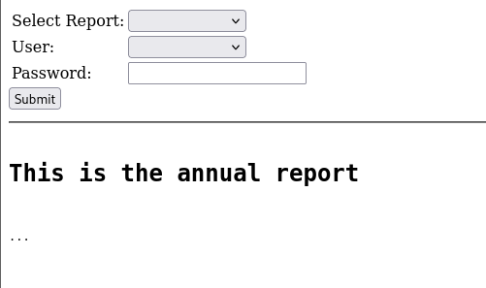
Figure 18: SQL Injection on Web Application
(Source: Self-Created)
Upon this input being submitted through the login form, access was granted without providing valid credentials, which fit the classic example of an authentication bypass through SQL injection (Poll, 2022). This exposed serious flaws in the input validation and back-end query processing.
A potent automated SQL injection tool, to further validate the injection location and retrieve data from the underlying database. The subsequent command was run:
sqlmap -u http://192.168.199.8/reports.php --forms --method POST \
--data="User=admin&Password=abc123&Submit=Submit" --batch --dump-all
SQLMap Findings:
- Two valid users were extracted:
  - abondman with password sunshine1
  - bbondman with password trustno1
- The database also contained a reports table with file paths and filenames.
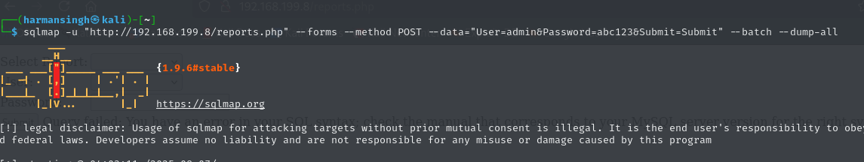
Figure 19: SQLMap SQL Injection Attack
(Source: Self-Created)
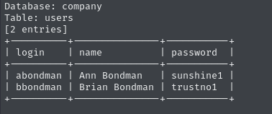
Figure 20: Database Dump Showing User Credentials
(Source: Self-Created)
These credentials were then tested over SSH and successfully authenticated to the CentOS 7 system using:
ssh abondman@192.168.199.8
This greatly increased the attack surface by offering a non-root user shell and verifying actual system access through database exploitation.
A classic example of a major online application vulnerability, the SQL injection vector not only circumvented authentication but also made private credentials public and allowed for unauthorised shell access.
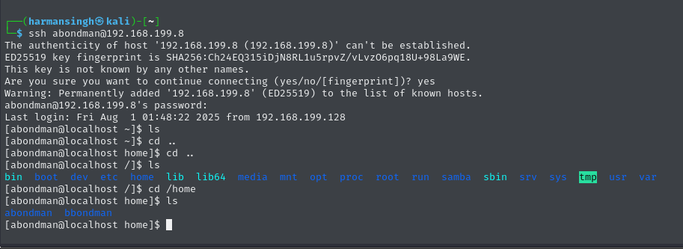
Figure 21: SSH to Internal Host as Non-Privileged User
(Source: Self-Created)

4.6 Pivoting
The last step of the evaluation was pivoting, which is using one compromised host to access other internal machines on the same network after taking control of the Windows 7 and CentOS 7 computers.
Pivot via Windows 7 (Meterpreter)
Using Metasploit’s Meterpreter session on Windows 7 loaded the post/multi/manage/autoroute module to route traffic through the existing session.
This enabled the attacking machine (Kali Linux) to interact with other hosts on the 192.168.199.0/24 subnet through the Windows 7 foothold.
Internal Resource Discovery
After establishing the path carried out enumeration and internal scans. Among the systems found was:
Discovered an open SMB share named Reports accessible via:
smbclient //192.168.199.8/Reports -N
Files found:
- annual.txt
- quaterly.txt
- monthly.txt
Looked over and downloaded these materials. They attested to the fact that internal data was unprotected and accessible after the pivot, even if it was not personally sensitive.

5. Results
Summary of Key Findings
Host | Vulnerability | Impact
Windows 7 | Sticky Keys backdoor (sethc.exe) | Full SYSTEM access without a password
CentOS 7 | GRUB root reset (rd.break) | Root access without authentication
CentOS Web App | SQL Injection (' OR 1=1; --<) | Auth bypass, credential leak
Internal Network | No segmentation or access controls | Allowed unrestricted pivoting
SMB Share | No authentication is required on the shared folder | Data exposure to all internal users

These results show how a motivated attacker might use simple methods to compromise several computers in a few hours by taking advantage of common configuration errors and security flaws.
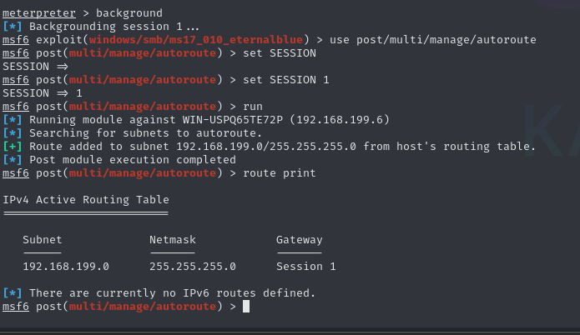
Figure 22: Pivoting Setup using Metasploit
(Source: Self-Created)
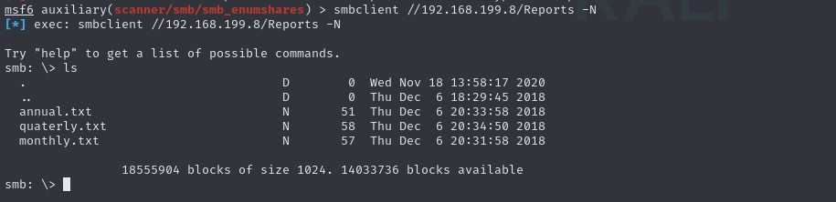
Figure 23: Retrieving Sensitive Files from SMB Share
(Source: Self-Created)

6. Recommendations
The following steps are advised to lessen the vulnerabilities found in this assessment:
Windows 7
- Disable or secure access to accessibility tools like sethc.exe at the login screen.
- Apply full-disk encryption and BIOS/UEFI password protection.
- Disable SMBv1 protocol and patch for MS17-010 (EternalBlue) vulnerabilities if not already done.
CentOS 7
- Set a GRUB bootloader password to prevent unauthorised boot parameter editing.
- Regularly update system packages and kernel to prevent local privilege escalation.
Web Application
- Use input sanitisation and prepared statements to stop SQL injection.
- Disable HTTP TRACE and directory listing.
- Use multi-factor authentication for login portals.
Internal Network
- Use firewalls and VLANs to divide the network into segments to prevent lateral movement.
- Monitor internal traffic for suspicious activity.
- Limit rights and demand authentication for all file sharing.
Summary of Vulnerabilities, Likelihood, Impact, and Time-to-Fix
Vulnerability | Likelihood | Impact | Risk (L × I) | Severity | Time-to-Fix
Sticky Keys Backdoor | High | High | High × High = Critical | Critical | < 7 days
EternalBlue (SMBv1) | High | Critical | High × Critical = Critical | Critical | < 7 days
SQL Injection (CentOS) | High | Critical | High × Critical = Critical | Critical | < 7 days
No Network Segmentation | High | High | High × High = Critical | Critical | < 30 days
Weak SSH Security | Medium | High | Medium × High = High | High | < 30 days
Weak Password Policies | High | Medium | High × Medium = High | High | < 30 days
Lack of Monitoring | Medium | Medium | Medium × Medium = Medium | Medium | < 60 days

7. Conclusion
This penetration test exhibited three types of threats: an incorrect configuration, an unpatched vulnerability in the application, and the assumption that the network is flat. The process started with a successful local privilege escalation attack on Windows 7 and CentOS 7, and then it went for the full compromise of the database through SQL injection. The last step in the assessment was pivoting to internal resources-a demonstration of the full power an attacker gets once he manages to get initial access (Open-Source Security Operations Center (SOC), 2024). Each step was very carefully carried out in the lab-controlled environment to best emulate the adversary's tradecraft and techniques: a real-world breach scenario.
In the passive assessment engagement, it emerged the tell-tale sign that legacy exploits and even simple misconfigurations, such that the entire system and network can be compromised-were casino settings that were employed. The results of this report serve as a reemphasis on the importance of keeping systems promptly updated, good access control policies, and correct network segmentation to avoid lateral movement by an attacker. The report concludes with a note of urgency that immediate measures be taken to address the vulnerabilities found throughout the test. To diminish these risks, the defence-in-depth approach should be established, building almost equally strong perimeters and internal defence systems, to secure the environment from both already identified and those that may emerge.

References
Abdeslam Rehaimi, Yassine Sadqi, Maleh, Y., Gurjot Singh Gaba, & Andrei Gurtov. (2024). Towards a federated and hybrid cloud computing environment for sustainable and effective provisioning of cyber security virtual laboratories. Expert Systems with Applications, 124267–124267. https://doi.org/10.1016/j.eswa.2024.124267
Alexis, V. (2021). Vulnerability Assessment of Computer Systems. https://ikee.lib.auth.gr/record/329019/files/GRI-2021-30112.pdf
Gonzalez, L., & Napetvaridze, S. (2025). Hardening University Servers Against Threat Actors : Enhanced Security Measures. DIVA. https://www.diva-portal.org/smash/record.jsf?pid=diva2:1926000
Le, P.-H. P., Dang, L. X., Do, Q. N., Hoang, C. N., & Nguyen, L. V. (2025). EternalBlue Exploit: Definitions and Working Mechanism. Algorithms for Intelligent Systems, 1–13. https://doi.org/10.1007/978-981-96-1452-3_1
May, R., Biermann, C., Krüger, J., & Leich, T. (2025). Asking Security Practitioners: Did You Find the Vulnerable (Mis)Configuration? VaMoS ’25: Proceedings of the 19th International Working Conference on Variability Modelling of Software-Intensive Systems. https://doi.org/10.1145/3715340.3715439
Open-Source Security Operations Center (SOC). (2024). Google Books. https://books.google.com/books?hl=en&lr=&id=-t0jEQAAQBAJ&oi=fnd&pg=PA63&dq=The+last+step+in+the+assessment+was+pivoting+to+internal+resources-a+demonstration+of+the+full+power+an+attacker+gets+once+he+manages+to+get+initial+access&ots=EWu2GlX_Ue&sig=8vhyilBiJCgyfUKD4r77XNOBPIY
Poll, E. (2022). Secure Input Handling. https://www.cs.ru.nl/~erikpoll/papers/secure_input_handling.pdf
Surya, A., Made, G., & Agus, P. (2024). Web Application Penetration Testing on Udayana University’s OASE E-learning Platform Using Information System Security Assessment Framework (ISSAF) and Open Source Security Testing Methodology Manual (OSSTMM). International Journal of Information Technology and Computer Science, 16(2), 45–56. https://doi.org/10.5815/ijitcs.2024.02.04

